CS 255 System Design Document Template

This template lays out all the different sections that you need to complete for Project Two. Each section has guidance to prompt your thinking. You will need to continually reference the interview transcript as you work to make sure that you are addressing your client’s needs. There is no required length for the final document. Instead the goal is to complete each section based on what your client’s needs are. Remove this note when you are finished, and replace all bracketed text with the relevant information.

UML Diagrams

UML Use Case Diagram

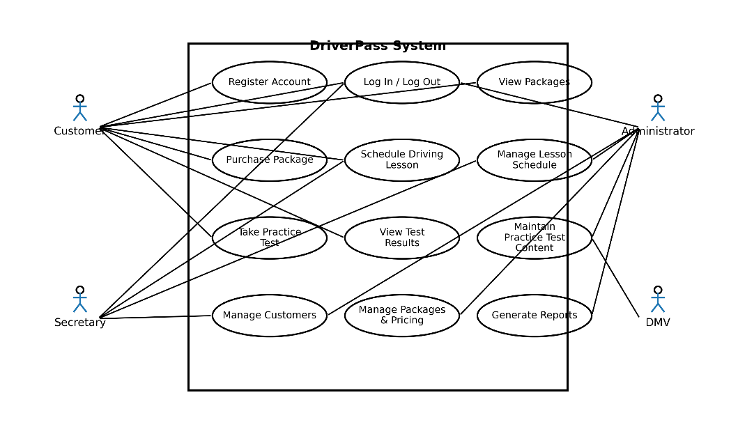

UML Activity Diagrams
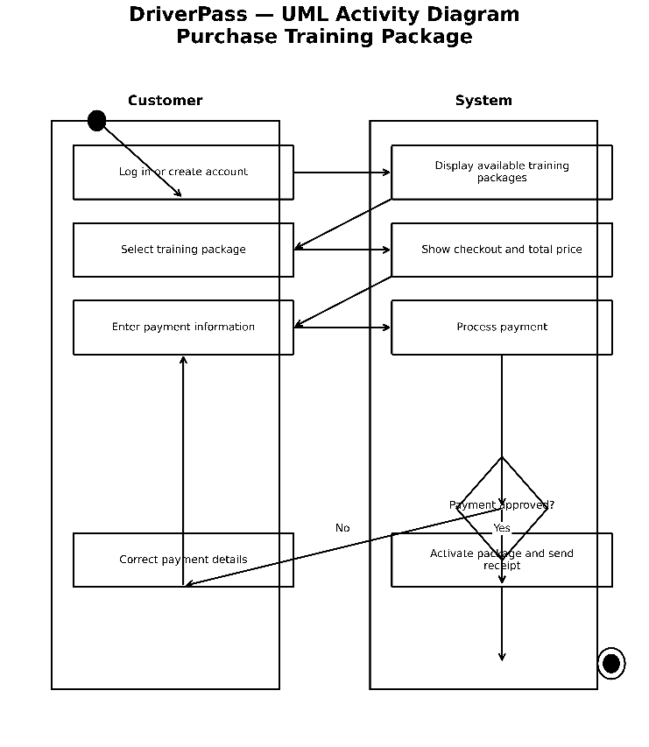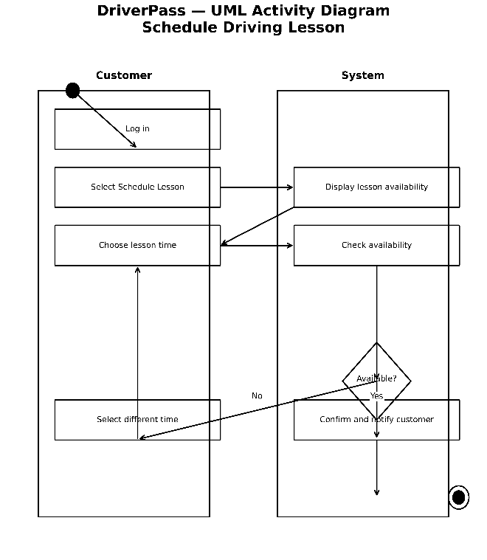

UML Sequence Diagram
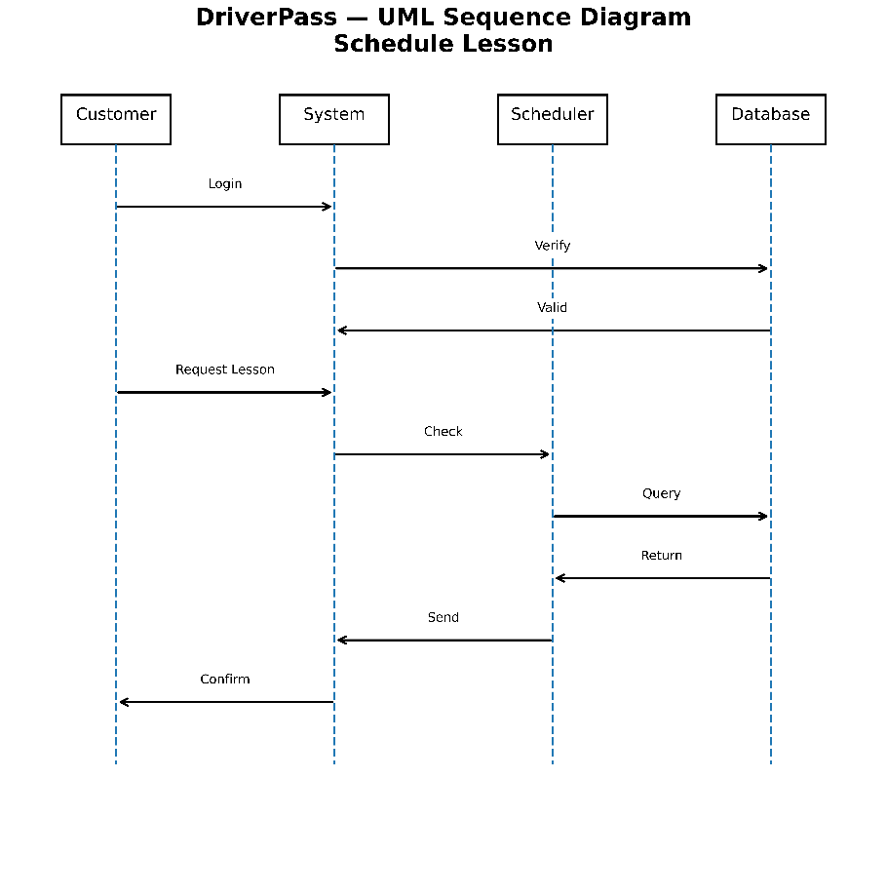

UML Class Diagram
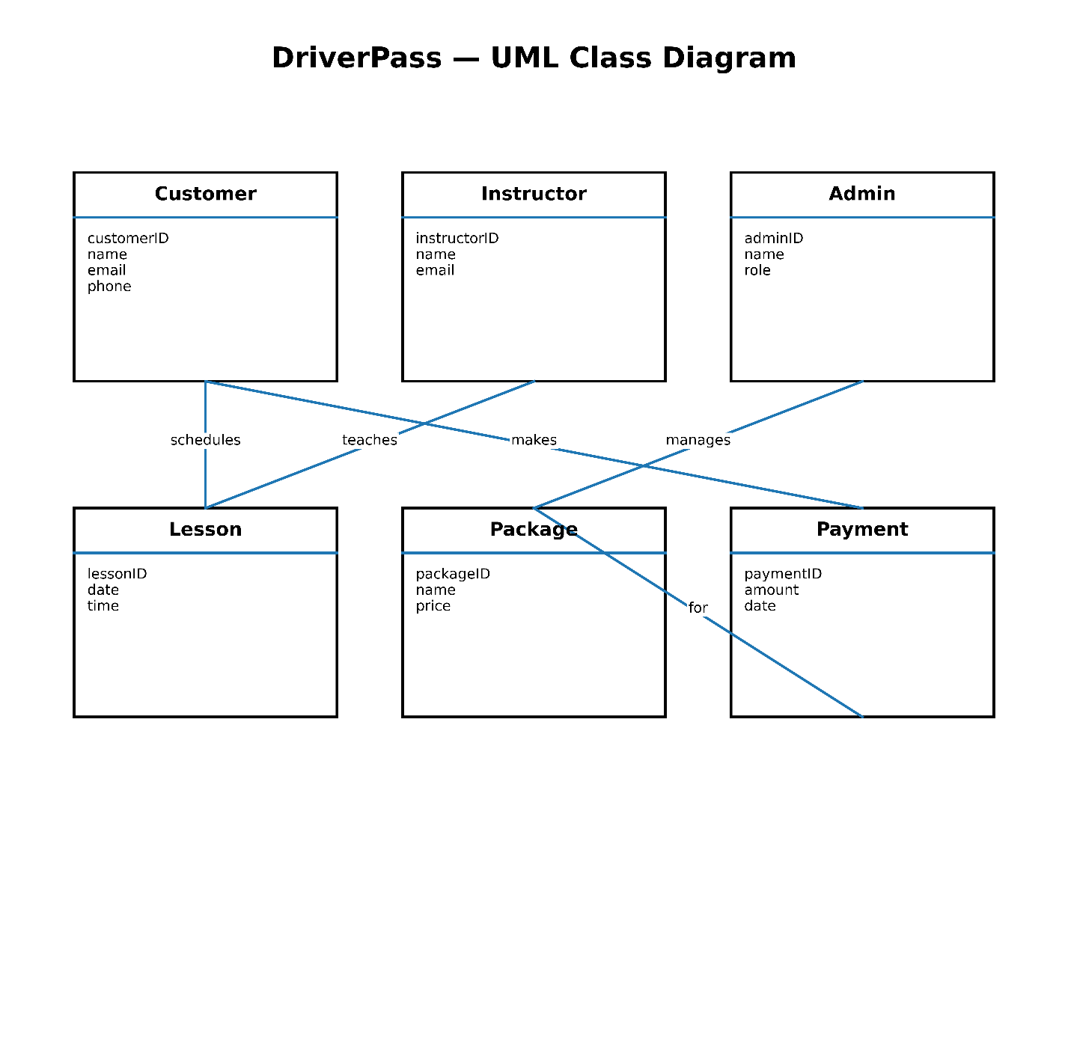

Technical Requirements
Hardware Requirements
- Desktop or laptop computers for employees
- Smartphones or computers for customers
- Secure servers to store system data
- Reliable internet connection

Software Requirements
- Web browser (Chrome, Edge, Safari)
- Web-based application for DriverPass
- Database software to store customer and lesson information
- Operating systems such as Windows or MacOS

Infrastructure Requirements
- Internet hosting service
- Cloud storage for data backup
- Secure login system
- Payment processing system

Tools Required
- Lucidchart for system design diagrams
- Programming tools for system development
- Database management tools

